Game Design Document

Fill up the following document

1. Write the title of your project.

Space war

1. What is the goal of the game?

Protect your planet from enemy

1. Write a brief story of your game.

Some greedy enemies trying to capture all plantes in our galaxy ,

And right now they are in the position to take our planet in their control .

One of our brave captain vikram ready with his whole power with our best spaceship and will be protect our planet and life on our planet.

So help him to protect our planet from greedy enemies !!

!!!Please help him!!!

1. Which are the playing characters of this game?

* Playing characters are the ones who respond to the user based on the input from the user.
* Cars, monkeys, dinos, wizards, etc., are the playing characters in the game.

|  |  |  |
| --- | --- | --- |
| Number | Character Name | What can this character do? |
| 1 | Captain vikram | Leader/warrior |
| 2 | Spaceship of enemy | Attack on our planet |
| 3 |  |  |
| 4 |  |  |
| 5 |  |  |
| 6 |  |  |
| 7 |  |  |
| 8 |  |  |

1. Which are the Non-Playing Characters of this game?

* Non-Playing characters are the ones that don't have an action or behavior when the user interacts with the game.
* Hurdles, stones, bananas, coins, etc., are non-playing characters in the game.

|  |  |  |
| --- | --- | --- |
| Number | Character Name | What can this character do? |
| 1 | astroide | Destroy our ship |
| 2 | stone | Destroy our ship |
| 3 |  |  |
| 4 |  |  |
| 5 |  |  |
| 6 |  |  |
| 7 |  |  |
| 8 |  |  |

Draw your imagination of this game. What does this game look like?

* Draw the game either on your computer or on paper.
* Add images of the game scenes to show each of the playing and non-playing characters at least once.

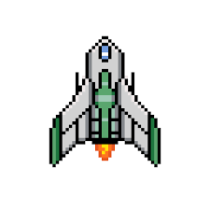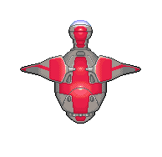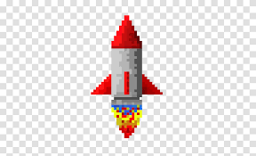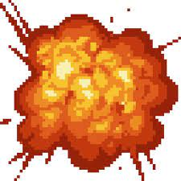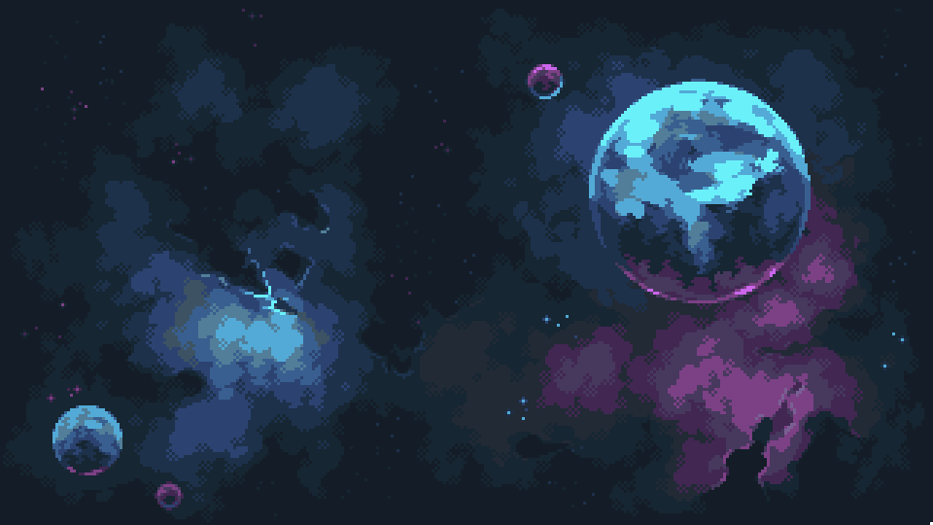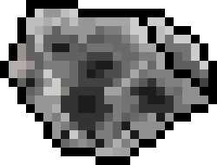

How do you plan to make your game engaging?

Attraction,attention and continues concentration of player will be planned to engage with game.